**SMART 8 CHANNEL RELAY BOARD (Version A)**

Smart 8 channel relay board consists of 8 relays and It also consists of ULN2803A which is the ground driver.

**POWER SUPPLY:**

A supply voltage of 12V should be connected, to power the relay coils when they are switched on. A power indicator LED indicates whether the power is supplied or not.

**APPLICATIONS:**

It is a simple and convenient way to interface 8 relays for switching applications.

It can be used to drive high voltage loads and it can be used in home automations.

**HOW TO USE:**

Connect a USB to Serial converter to the board and give commands from serial monitor.

The commands to the board is given as follows:

(Example:10 where 1 indicates relay number and 0 indicates the status of relay.)

10- Relay1 is turned off

11- Relay1 is turned on

20- Relay2 is turned off

21- Relay2 is turned on

The same continues for all the 8 relays.

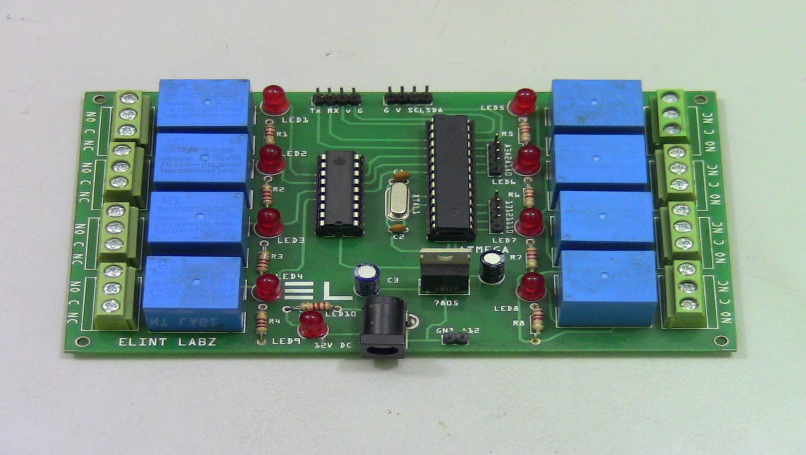

A relay is an electrically operated switch. Current flowing through the coil of the relay creates a magnetic field which attracts a lever and changes the switch contacts. The coil current can be on or off so relays have two switch positions and they are double throw (changeover) switches.

The relay’s switch connections are usually labeled COM(POLE), NC and NO:

COM/POLE= Common, NC and NO always connect to this, it is the moving part of the switch.

NC = Normally Closed, COM/POLE is connected to this when the relay coil is not magnetized.

NO = Normally Open, COM/POLE is connected to this when the relay coil is MAGNETIZED and vice versa.